E-Commerce Sales Analytics Dashboard

A Project Report Submitted in the partial fulfillment of the requirements for the award of the degree of

BACHELOR OF TECHNOLOGY
In

DEPARTMENT OF COMPUTER SCIENCE AND ENGINEERING
By
Student Name | :K. HARSHITH VARMA (2420030013)
Student Name | :G. SANTHOSH (2420030123)
Student Name | :K. SAI DANUSH (2420030769)

Under the Esteemed Guidance of

Dr. N. Sunanda
Associate Professor
Department of CSE

Department of Computer Science and Engineering

AY- 2026-2027

Semester: 3rd




K L (Deemed to be) University
DEPARTMENT OF COMPUTER SCIENCE AND ENGINEERING

Declaration

The Project Report entitled “E-Commerce Sales Analytics Dashboard” is a record of Bonafide work of K. Harshith Varma – 2420030013, G. Santhosh – 2420030123, K. Sai Danush – 2420030769 submitted in partial fulfillment for the award of B. Tech in Computer Science and Engineering to the K L University. The results embodied in this report have not been copied from any other departments/University/Institute.

K. Harshith Varma – 2420030013
G. Santhosh – 2420030123
K. Sai Danush – 2420030769

K L (Deemed to be) University
DEPARTMENT OF COMPUTER SCIENCE AND ENGINEERING

CERTIFICATE

This is to certify that the project report entitled "AGRI-INTELLIGENCE: AI-POWERED SMART CROP MANAGEMENT & DECISION SUPPORT SYSTEM" is a bonafide work carried out and submitted by K. Harshith Varma – 2420030013, G. Santhosh – 2420030123, K. Sai Danush – 2420030769 in partial fulfillment of the requirements for the award of the degree of BACHELOR OF TECHNOLOGY in Department of Computer Science and Engineering, K L (Deemed to be) University, during the academic year 2026–2027.

_____________________  Signature of the Guide  Dr. N. Sunanda  Associate Professor, CSE | _____________________  Course Coordinator  Dr. N. Sunanda  Department of CSE | _____________________  Head of the Department  Dr.P. Venkateswara Rao  Department of CSE

ACKNOWLEDGEMENT
The success of this project would not have been possible without the timely help and guidance rendered by many people. We express our sincere thanks to all those who have assisted us in one way or the other in the completion of our project.

Our greatest appreciation to our Course Coordinator and our guide Dr. N. Sunanda, Department of Computer Science and Engineering, for the tremendous support, encouragement and guidance given for this project.

We express our gratitude to Dr. Venkateshwar Rao, Head of the Department of Computer Science and Engineering, for providing us with adequate facilities, ways and means by which we were able to complete this project.

We thank all the members of the teaching and non-teaching staff who have assisted us directly or indirectly in the successful completion of this project. Finally, we sincerely thank our parents, friends and classmates for their kind help and cooperation during our work.

K. Harshith Varma – 2420030013
G. Santhosh – 2420030123
K. Sai Danush – 2420030769

Abstract
E-commerce platforms generate large volumes of order, product, customer and payment data every day. In its raw form, this data is difficult to read and interpret quickly, so useful patterns such as best-selling products, strong categories, regional differences and monthly sales trends often remain hidden from business owners and sales teams.

This project, the E-Commerce Sales Analytics Dashboard, presents an end-to-end workflow that turns raw sales records into a single interactive dashboard. The workflow covers data collection, data cleaning (handling missing, duplicate and incorrect records), exploratory data analysis (EDA), calculation of sales KPIs such as gross revenue, unique orders, average order value (AOV) and units sold, and visualization of product, category, regional, payment-method and time-based performance. The system is implemented in Python using Pandas and NumPy for data handling, Matplotlib and Seaborn for charts, and Streamlit for the dashboard interface.

The prototype was demonstrated on a generated sample dataset of 96 order records with eight fields. It produced a gross revenue of Rs. 512,813 from 96 unique orders, an average order value of Rs. 5,342 and 192 units sold, with Electronics as the leading category and Smart Watch as the leading product. These figures illustrate the dashboard calculations and are to be recalculated when the final verified dataset is used. The project brings preparation, analysis and visualization together in one workflow so that users can review sales, products, categories and regions side by side and make better, data-driven business decisions.

Index
S. No. | Chapters | Topics | Page.no
 |  | Acknowledgement | 4
 |  | Abstract | 5
1 | Introduction | 1.1 Background of the project  1.2 Problem statement  1.3 Scope of the project  1.4 Objective(s)  1.5 Importance of the application  1.6 Target users/audience | 1-3
2 | System Requirements | 2.1 Hardware requirements  2.2 Software requirements  2.3 Development tools and frameworks | 4
3 | Technology Stack | 3.1 Front-end (e.g., React.js, Angular, HTML/CSS)  3.2 Back-end (e.g., Node.js, Django, Spring Boot)  3.3 Database (e.g., MongoDB, MySQL, PostgreSQL)  3.4 Version Control (e.g., Git, GitHub)  3.5 APIs or External services (e.g., Firebase, Stripe) | 5-6
4 | System Architecture | 4.1 High-level architecture diagram  4.2 Description of each layer (frontend, backend, database)  4.3 Deployment architecture (e.g., cloud, local, CI/CD pipelines) | 7-8
5 | Design | 5.1 Wireframes or mockups  5.2 ER Diagram / Database schema | 9-10
6 | Implementation | 6.1 Module-wise implementation  6.2 Front-end logic (UI rendering, state management)  6.3 Backend logic (routes, controllers, business logic)  6.4 Database connectivity  6.5 API integration  6.6 Authentication & Authorization | 11-14
7 | Features | 7.1 List of main features  7.2 How each feature works (user perspective + technical description) | 15-16
8 | Testing | 8.1 Postman testing (frontend/backend)  8.2 Integration testing  8.3 Tools used for testing  8.4 Test cases and results | 17-18
9 | Deployment | 9.1 Steps to deploy  9.2 Environment configuration  9.3 Hosting of frontend and backend | 19
10 | Challenges & Limitations | 10.1 Issues faced during development  10.2 Solutions applied  10.3 Current limitations or known bugs | 20
11 | Future Enhancements | 11.1 Planned features  11.2 Possible integrations or optimizations | 21
12 | Conclusion | 12.1 Summary of the project  12.2 What was achieved  12.3 Skills learned during development | 22
13 | References | - Books, tutorials, APIs, documentation sites used | 23
14 | Appendices | - Screenshots of the app  - Sample code snippets  - Installation/setup instructions  - User manual or guide  -certifications | 24-25

CHAPTER 1
Introduction
1.1 Background of the project
E-commerce platforms generate large volumes of order, product, customer and payment data. Every purchase creates a record that includes what was bought, in what quantity, at what price, on which date, from which region and by which payment method. Analysing this information helps businesses understand their performance and the purchasing patterns of their customers.
Data analytics and business intelligence (BI) dashboards have become the standard way of converting such records into decisions. A dashboard collects the most important measures, known as Key Performance Indicators (KPIs), and displays them along with charts and comparisons on a single screen. Instead of reading thousands of rows, a manager can see total revenue, the number of orders, the average order value and the top-selling products at a glance.
The E-Commerce Sales Analytics Dashboard developed in this project follows this approach. It uses Python-based data analysis and an interactive dashboard prototype to summarise e-commerce sales performance.
1.2 Problem statement
Raw sales records are difficult to interpret quickly. A business owner who only has a spreadsheet of orders cannot easily answer questions such as which category earns the most, which product sells best, how revenue changes from month to month, or which region and payment method are most used. Without a consolidated view, useful patterns may remain hidden.
The project addresses this problem by bringing the key sales metrics and comparisons into one dashboard, using data cleaning, exploratory data analysis and visualizations.
1.3 Scope of the project
The scope of the project is defined as follows.
- In scope: collecting e-commerce sales records; cleaning missing, duplicate and incorrect records; converting dates and numeric fields to suitable data types; calculating sales KPIs (revenue, unique orders, average order value, units sold); ranking products; comparing categories, regions, payment methods and months; and presenting the results through an interactive dashboard.
- Implementation focus: Python-based data analysis and an interactive dashboard prototype.
- Type of analytics: descriptive analytics. The project does not train a supervised machine learning model, so data splitting into training and test sets is not applicable.
- Out of scope (future enhancement): cloud deployment, scheduled data refresh, role-based access and customer segmentation.
1.4 Objective(s)
The objectives of the project are:
- To build an interactive dashboard that summarizes e-commerce sales performance.
- To clean missing, duplicate and incorrect records so that the analysis is reliable.
- To perform exploratory data analysis (EDA) and calculate sales KPIs.
- To visualize product, category, regional and time-based performance.
1.5 Importance of the application
Business owners and sales teams can use the dashboard to identify trends, popular products and category or regional differences. The application is important because it:
- saves time by replacing manual reading of raw records with ready-made KPI cards and charts;
- reveals trends over time, such as months with high or low revenue, which helps in planning stock and promotions;
- highlights leading products and categories so that attention and inventory can be directed to them;
- allows comparison across categories, regions and payment methods in one place; and
- supports data-driven decision making instead of decisions based on guesswork.
1.6 Target users/audience
The intended users of the application are business owners, sales teams and data analysts working with e-commerce sales data. The dashboard can also be used by students and academic reviewers as an example of an end-to-end data analytics workflow.
CHAPTER 2
System Requirements
2.1 Hardware requirements
The project is a Python-based prototype and does not need specialised hardware. The following are sufficient:
- A standard laptop or desktop computer.
- Sufficient storage for the dataset and project files.
- A network connection for data access and for installing the required libraries.
2.2 Software requirements
Software | Purpose
Python 3.x | Core programming language used for data cleaning, analysis and dashboard logic
Pandas / NumPy | Data handling, cleaning, aggregation and numerical calculations
Matplotlib / Seaborn | Creation of bar, line and comparison charts
Streamlit | Interactive dashboard interface displayed in the web browser
Web browser | Viewing the dashboard (for example Chrome, Edge or Firefox)
Operating system | Windows, Linux or macOS

2.3 Development tools and frameworks
- VS Code / Jupyter Notebook: writing code and carrying out step-by-step exploratory analysis.
- Git: version control of the project files and collaboration among team members.
- Libraries and frameworks: Pandas, NumPy, Matplotlib, Seaborn and Streamlit, as listed in Chapter 3.
CHAPTER 3
Technology Stack
The technology stack of the project is entirely Python based. This keeps the system simple, easy to run on a normal computer and easy for the team to maintain.
3.1 Front-end (e.g., React.js, Angular, HTML/CSS)
The user interface is built with Streamlit, a Python framework that turns Python scripts into interactive web applications without writing separate HTML, CSS or JavaScript. KPI cards, filters, tables and charts are rendered directly in the browser. Charts are drawn using Matplotlib and Seaborn, which provide bar charts, line charts and other statistical plots.
3.2 Back-end (e.g., Node.js, Django, Spring Boot)
The back-end logic is written in Python 3.x. Pandas is used to load the records, inspect the schema, remove duplicates, handle missing values, convert data types, group the data and sort the results. NumPy supports numerical operations. No separate web server framework such as Django or Spring Boot is required, because Streamlit runs the Python code and serves the page.
3.3 Database (e.g., MongoDB, MySQL, PostgreSQL)
The current prototype does not use a database server. The sales records are stored as a tabular file (CSV / order records) and loaded into a Pandas DataFrame at run time. The dataset has eight fields: order ID, date, product, category, quantity, revenue, region and payment. For larger data volumes, the file source can later be replaced with a relational database such as MySQL or PostgreSQL.
3.4 Version Control (e.g., Git, GitHub)
Git is used for version control so that the code written by the three team members can be combined, tracked and restored if required. A remote repository link has not been supplied at the time of writing and can be added to the references section.
3.5 APIs or External services (e.g., Firebase, Stripe)
The prototype does not depend on any external API or third-party service. All processing is done locally on the dataset. Integration with live e-commerce platform APIs is listed as a future enhancement.
CHAPTER 4
System Architecture
4.1 High-level architecture diagram
The system follows an end-to-end data flow that starts with raw sales records and ends with an interactive dashboard. Figure 4.1 shows the five stages of the architecture.
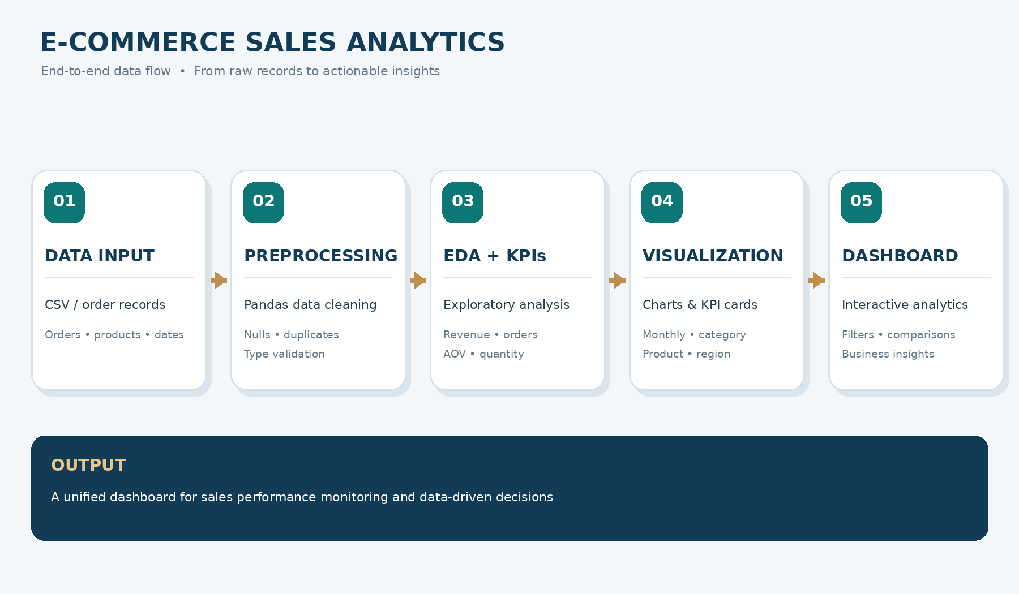
Fig No. 4.1 System architecture (end-to-end data flow)
4.2 Description of each layer (frontend, backend, database)
Stage | Layer | Description
01 Data Input | Data / storage layer | CSV / order records containing orders, products and customers' purchase details.
02 Preprocessing | Back-end | Pandas data cleaning: handling nulls and duplicates, correcting invalid records, and converting dates and numeric fields to proper data types.
03 EDA + KPIs | Back-end | Exploratory analysis and KPI calculation: revenue, orders, average order value, units sold, and rankings by product and category.
04 Visualization | Front-end | Charts and grouped comparisons: monthly trend, category, region and payment method.
05 Dashboard | Front-end | Interactive Streamlit dashboard with KPI cards, filters, comparisons and business insights.

In summary, a unified dashboard for sales performance monitoring and data-driven decisions is produced from the raw records.
4.3 Deployment architecture (e.g., cloud, local, CI/CD pipelines)
The current deployment is local: the dashboard runs on the user's laptop or desktop and is opened in a web browser. No cloud services or CI/CD pipelines are used in the prototype. Cloud deployment, so that authorized business users can open the dashboard through a link, is identified as a future enhancement (see Chapter 11).
CHAPTER 5
Design
5.1 Wireframes or mockups
The dashboard is designed as a single screen with a navigation panel on the left, KPI cards across the top, and chart areas below. Figure 5.1 shows the dashboard preview of the prototype. The main areas are:
- Navigation panel: Overview, Performance, Products and Customers.
- KPI cards: Gross Revenue, Unique Orders, Average Order Value and Units Sold.
- Sales over time: a monthly revenue bar chart.
- Top products: a horizontal bar chart of the best-selling products.
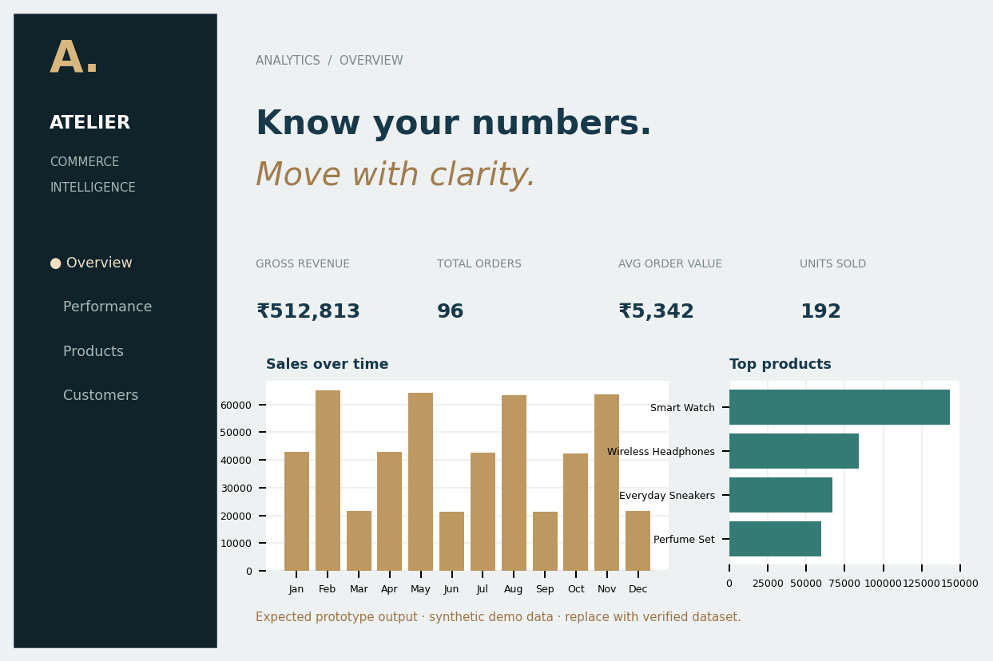
Fig No. 5.1 Dashboard preview with KPI cards, monthly sales and top products
5.2 ER Diagram / Database schema
Because the project works on one flat table of orders, the schema consists of a single entity with eight attributes. Each row represents one order record.
S.No | Field | Description | Type
1 | Order ID | Unique identifier of an order (used to count unique orders) | Text
2 | Date | Date of the order (used for monthly trends) | Date
3 | Product | Name of the product sold | Text
4 | Category | Product category, e.g. Electronics, Fashion, Beauty, Home | Text
5 | Quantity | Number of units sold in the order | Integer
6 | Revenue | Order amount in rupees | Decimal
7 | Region | Sales region of the order, e.g. South, West, North | Text
8 | Payment | Payment method, e.g. Credit Card, Debit Card, UPI, Cash on Delivery | Text

Relationships between product, category, region and payment are derived by grouping the single table; therefore no foreign keys are required in the current design.
CHAPTER 6
Implementation
6.1 Module-wise implementation
The project is divided into four modules. The work was distributed among the team members as shown below.
No. | Module | Purpose | Input -> Output | Developed by
1 | Data Collection & Preprocessing | Collects and prepares reliable records | Raw data -> cleaned dataset | K. Harshith Varma
2 | Data Analysis & Insights | Explores sales patterns and calculates business metrics | Clean data -> KPI tables and insights | G. Santhosh
3 | Dashboard & Visualization | Presents metrics through charts and dashboard views | Analysis results -> visual dashboard | K. Sai Danush
4 | KPI & Validation | Checks calculations and consistency of displayed results | KPI/chart outputs -> verified results | Team

Module 1: Data Collection and Preprocessing
The dataset is loaded and its schema is inspected. Null values and duplicate records are identified, invalid records are corrected or removed according to documented cleaning rules, and dates and numeric fields are converted to suitable data types. The output is a cleaned dataset ready for analysis. The cleaned data preview is shown in Figure 6.1.
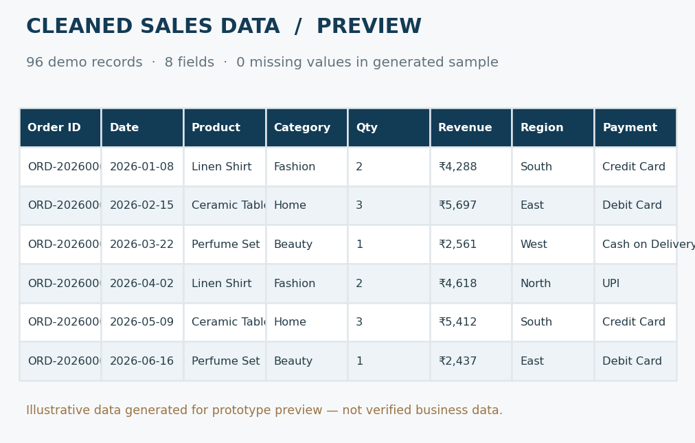
Fig No. 6.1 Cleaned data preview (96 records, 8 fields, 0 missing values)
Module 2: Data Analysis and Insights
This module performs exploratory data analysis and calculates the sales KPIs. Records are grouped by product, category, region, payment method and month, and the results are sorted in descending order of revenue to rank the leading products and categories.
Module 3: Dashboard and Visualization
This module creates the charts, KPI cards and dashboard views that present the analysis clearly to the user.
Module 4: KPI and Validation
This module checks that the totals match the source records, that unique order counts are correct and that the charts show consistent values.
6.2 Front-end logic (UI rendering, state management)
The dashboard interface is rendered with Streamlit. The KPI values computed in the analysis module are displayed as metric cards, and the grouped results are passed to Matplotlib / Seaborn to draw the charts. When the user changes a selection, Streamlit re-runs the script and the cards and charts are updated consistently with the selected data. Streamlit's session handling keeps the selected values, so no separate state-management library is needed.
6.3 Backend logic (routes, controllers, business logic)
The prototype has no separate routes or controllers; the business logic is a data processing pipeline written in Python:
Load data -> inspect schema -> handle missing, duplicate and invalid records -> convert data types -> prepare analysis fields -> calculate KPIs -> group and rank -> render KPI cards and charts.
The business rules are: unique order IDs are used for order counts; sales are grouped by product, category, region and date; and only valid order amounts are included in revenue. The KPI formulas are:
- Gross Revenue = sum of valid order revenue
- Unique Orders = count of distinct order IDs
- Average Order Value (AOV) = Revenue / unique orders
- Units Sold = sum of quantity
The logic of the implementation is summarised in the following pseudocode:
sales = sum(valid_order_amounts)
orders = count_unique(order_id)
average_order_value = sales / orders
product_sales = group_by_product(sales)
top_products = sort_desc(product_sales)
render_kpis_and_charts()

6.4 Database connectivity
No database server is connected. The records are read from the dataset file into a Pandas DataFrame at start-up (for example with pandas.read_csv), and all further operations are performed in memory. Connectivity to a relational database can be added later by replacing the loading step.
6.5 API integration
No external APIs are integrated in the current version. The dashboard works entirely on the supplied dataset.
6.6 Authentication & Authorization
The prototype runs locally for the project team and reviewers, so authentication and authorization are not implemented. Role-based access and secure storage are planned as future enhancements for a deployed version.
CHAPTER 7
Features
7.1 List of main features
- Data cleaning of missing, duplicate and incorrect records.
- KPI cards for gross revenue, unique orders, average order value and units sold.
- Monthly sales trend chart.
- Top products ranking.
- Category-wise revenue comparison.
- Region-wise and payment-method-wise comparison.
- Interactive dashboard with a unified view of sales performance.
7.2 How each feature works (user perspective + technical description)
Feature | User perspective | Technical description
Data cleaning | The user works with reliable numbers without checking each row. | Pandas checks nulls and duplicates, corrects invalid values and converts dates and numeric fields.
KPI cards | The user sees revenue, orders, AOV and units at the top of the screen. | Aggregation: Revenue = sum of order revenue; AOV = Revenue / unique orders; Units = sum of quantity.
Monthly sales trend | The user sees how revenue changes across the months of the year. | Orders are grouped by month and the revenue totals are drawn as a bar / line chart.
Top products | The user sees which products sell best. | Revenue is grouped by product and sorted in descending order; the top items are charted.
Category comparison | The user compares Electronics, Fashion, Beauty and Home. | Revenue is grouped by category and displayed as a horizontal bar chart (Figure 7.1).
Region / payment comparison | The user sees which regions and payment methods dominate. | Group-by on the region and payment fields with summarised totals.

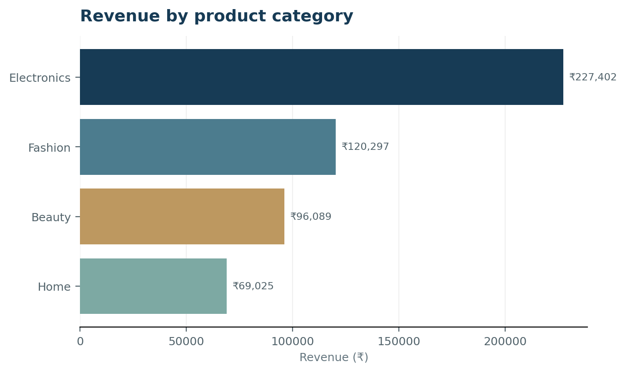
Fig No. 7.1 Revenue by product category
CHAPTER 8
Testing
The testing activities check that the data is prepared correctly, that the KPI calculations are right and that the dashboard displays consistent values. Because the project performs descriptive analytics and does not train a model, validation is done by comparing the computed results with manually checked sample records.
8.1 Postman testing (frontend/backend)
Postman is used to test REST API endpoints. The project does not expose any API (the back-end logic runs inside the Streamlit application), so Postman testing is not applicable. Instead, the front-end and the back-end logic are checked through functional testing of the dashboard itself.
8.2 Integration testing
Integration testing checks that the output of each module is correctly consumed by the next one: the cleaned dataset from the preprocessing module is accepted by the analysis module, the KPI tables are accepted by the visualization module, and the charts update consistently with the selected data.
8.3 Tools used for testing
- Python and Pandas: inspecting nulls, duplicates and data types, and recomputing totals independently.
- Manual verification: comparing KPI values and chart values against manually checked sample records.
- Web browser: checking that the Streamlit dashboard renders correctly.
8.4 Test cases and results
The test cases below were defined for the prototype using the 96-record demonstration dataset. The Actual Result and Status columns are to be completed by the team after running the tests on the final dataset.
Test ID | Test Description | Expected Result | Actual Result | Status
TC-01 | Check missing and duplicate records in the dataset | 0 missing values; no duplicate order IDs after cleaning
TC-02 | Check data-type conversion of date and numeric fields | Date is a date type; quantity and revenue are numeric
TC-03 | Verify gross revenue KPI against manually summed records | Rs. 512,813 for the demo dataset
TC-04 | Verify unique orders, average order value and units sold | 96 orders; AOV Rs. 5,342; 192 units
TC-05 | Verify that category totals add up to gross revenue | Electronics + Fashion + Beauty + Home = Rs. 512,813
TC-06 | Check charts update consistently with selected data | Charts and KPI cards change together
8.5 Screenshots of the app
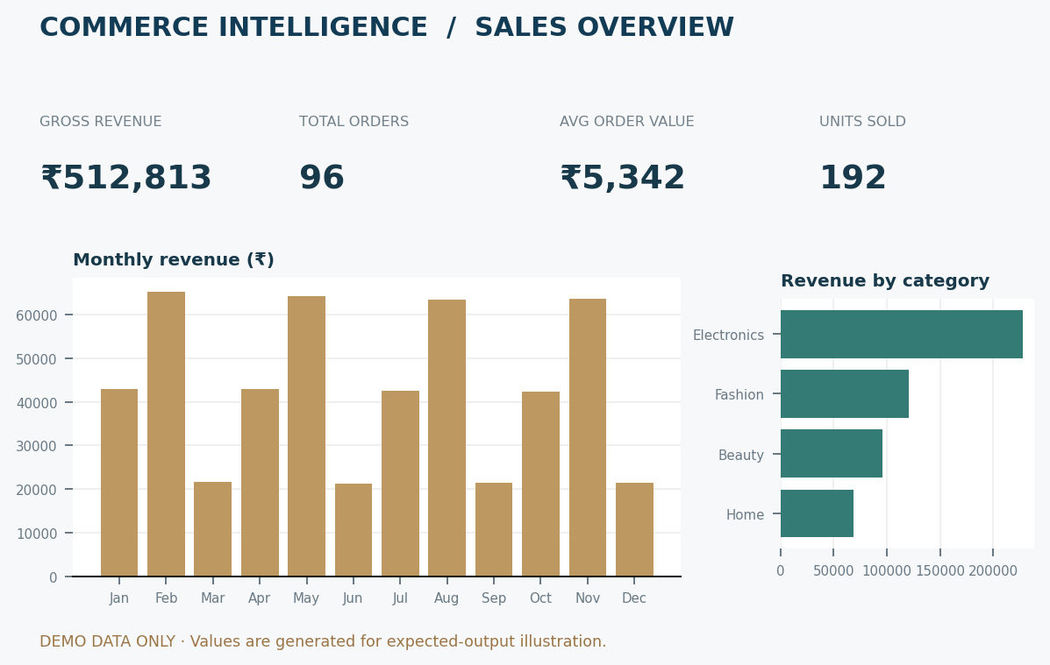
Fig No. 8.5.1 Sales metrics: gross revenue, unique orders, AOV, units sold, monthly revenue and revenue by category
Fig No. 8.5.2 Dashboard view with KPI cards, sales over time and top products
These screenshots show the prototype output generated from the 96-row demonstration dataset (expected output; not verified business results).
8.6 Sample code snippets
The following Python snippet illustrates the KPI and ranking logic described in Chapter 6. Column names follow the dataset schema in Section 5.2 and may be adjusted to the final dataset.
import pandas as pd

df = pd.read_csv("sales.csv") # load records
df = df.drop_duplicates() # remove duplicates
df = df.dropna(subset=["Order ID", "Revenue"]) # remove incomplete rows
df["Date"] = pd.to_datetime(df["Date"]) # convert data types
df["Revenue"] = pd.to_numeric(df["Revenue"])

revenue = df["Revenue"].sum()
orders = df["Order ID"].nunique()
aov = revenue / orders
units = df["Quantity"].sum()

top_products = (df.groupby("Product")["Revenue"]
.sum().sort_values(ascending=False))
monthly = df.groupby(df["Date"].dt.to_period("M"))["Revenue"].sum()

8.7 Installation/setup instructions
Follow the steps in Section 9.1: install Python 3.x, install the libraries with pip, place the dataset in the project folder and run the Streamlit application.
8.9 User manual or guide
- Start the application and open the dashboard in the browser.
- Read the KPI cards at the top for gross revenue, unique orders, average order value and units sold.
- Study the monthly sales chart to find high and low months.
- Use the top products and category charts to identify the best performers.
- Compare regions and payment methods to understand customer behaviour.

CHAPTER 9
Deployment
9.1 Steps to deploy
The prototype is run locally. The steps are:
- Install Python 3.x on the computer.
- Copy or clone the project folder (with the dataset file) from the Git repository.
- Install the required libraries: pip install pandas numpy matplotlib seaborn streamlit
- Open a terminal in the project folder and start the dashboard with: streamlit run <main script name>.py
- Open the local address shown in the terminal (normally http://localhost:8501) in a web browser.
9.2 Environment configuration
- Python 3.x with the libraries listed above installed (a virtual environment is recommended).
- The dataset file placed in the project folder, with the eight expected fields: order ID, date, product, category, quantity, revenue, region and payment.
- No API keys, database connections or environment variables are needed in the current version.
9.3 Hosting of frontend and backend
The front-end and back-end run together in a single Streamlit process on the local machine. Publishing the dashboard to a cloud platform for authorized business users, with scheduled data refresh and secure storage, is a planned future enhancement.
CHAPTER 10
Challenges & Limitations
10.1 Issues faced during development
- Missing or duplicate records in sales data.
- Inconsistent data types in date and numeric fields.
- Comparing multiple dimensions (product, category, region, payment and time) in a clear way.
10.2 Solutions applied
- Missing and duplicate records are inspected and handled by documented cleaning rules.
- Dates and numeric fields are standardized by explicit type conversion.
- Grouped summaries and clear charts are used to compare several dimensions without confusing the user.
10.3 Current limitations or known bugs
- The results shown in the prototype are based on a generated sample dataset of 96 records; they demonstrate the calculations and are not verified business results. They must be replaced with results from the team's verified dataset.
- The dashboard is a local prototype; cloud deployment, scheduled data refresh and role-based access are not yet implemented.
- The project is limited to descriptive analytics and does not forecast future sales.
CHAPTER 11
Future Enhancements
11.1 Planned features
- Add customer segmentation, repeat-purchase analysis and inventory indicators.
- Add scheduled data refresh so that the dashboard always shows current data.
- Add role-based access and secure storage for business users.
11.2 Possible integrations or optimizations
- Optimize data loading and aggregation for larger sales datasets.
- Publish the interactive dashboard to the cloud for authorized business users.
- Connect to a database or to live e-commerce platform data instead of static files.
Possible applications of the project include e-commerce business performance monitoring, product and inventory planning, and regional and category sales comparison.
CHAPTER 12
Conclusion
12.1 Summary of the project
The project defines an end-to-end workflow for cleaning, analysing and visualizing e-commerce sales data and presents the results in an interactive dashboard. The dashboard consolidates the key sales metrics and comparisons across products, categories, regions, payment methods and time periods, so that business performance becomes easier to understand.
12.2 What was achieved
- A data workflow covering collection, cleaning, EDA, KPI calculation and visualization was designed and implemented in Python.
- The prototype demonstrates revenue, order count, average order value and units sold: on the 96-record demonstration dataset it showed Rs. 512,813 gross revenue, 96 unique orders, an average order value of Rs. 5,342 and 192 units sold.
- In the demonstration data, Electronics was the top category (Rs. 227,402), followed by Fashion (Rs. 120,297), Beauty (Rs. 96,089) and Home (Rs. 69,025), and Smart Watch was the top product.
- The final figures are to be confirmed with the project's verified dataset.
12.3 Skills learned during development
- Data cleaning and preprocessing with Pandas and NumPy.
- Exploratory data analysis and KPI design for business data.
- Data visualization with Matplotlib and Seaborn, and dashboard building with Streamlit.
- Version control with Git and teamwork in a divided-module project.
- Testing and validation of analytical results.
CHAPTER 13
References
Books, research papers, tutorials and documentation sites used in the project:
[1] Ali, Aaron, Ahmed & Moses (2026), “Exploratory Data Analysis and Visualization of Amazon Sale Report Dataset using Tableau.” [Full publication details to be verified.]
[2] Aarthi, Veera Varaha Kesavan, Sandeep & Lokeshwar (2025), “E-Commerce Sales Analysis Dashboard: Real-Time Analytics for Business Growth.” [Details to be verified.]
[3] Patil, Kulkarni, Kaduskar, Shinde & Shahapurkar (2025), “Interactive E-Commerce Dashboard Using Power BI for Strategic Business Insights.” [Details to be verified.]
[4] Yadav, Lakshmi & Alekya (2024), “Retail Insights: Unveiling E-Commerce Dynamics with Power BI.” [Details to be verified.]
[5] Akter & Wamba (2016), “Big Data Analytics in E-commerce / Business Performance.” [Verify the exact title and publication.]
[6] Pandas documentation: https://pandas.pydata.org/docs/
[7] NumPy documentation: https://numpy.org/doc/
[8] Matplotlib documentation: https://matplotlib.org/stable/
[9] Seaborn documentation: https://seaborn.pydata.org/
[10] Streamlit documentation: https://docs.streamlit.io/
Project links: GitHub – not supplied; Dataset – generated prototype sample; Demo video – not supplied.

